# Microservices with Spring Boot 3 and Spring Cloud

# Microservices with API gateway

# Mandatory HandsOn

**Creating Microservices for account and loan**

**Account Microservice:**

* • Create folder with employee id .(eg:123456)
* • Create folder named 'microservices' in the new folder created in previous step. This folder will contain all the sample projects that we will create for learning microservices.



**Open https://start.spring.io/ in browser** •

* Enter form field values as specified below:

**Group:** com.cognizant

**Artifact:** account •

* Select the following modules :

Developer Tools > Spring Boot DevTools

Web > Spring Web •

* Click generate and download the zip file

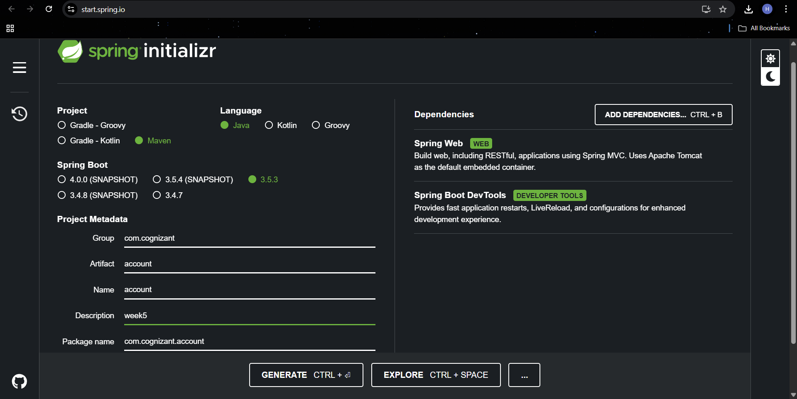

* Extract 'account' folder from the zip and place this folder in the 'microservices' folder created earlier

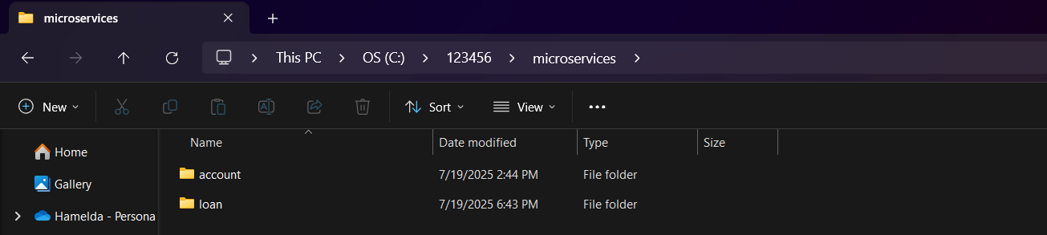

* Open command prompt in account folder and build using mvn clean package command

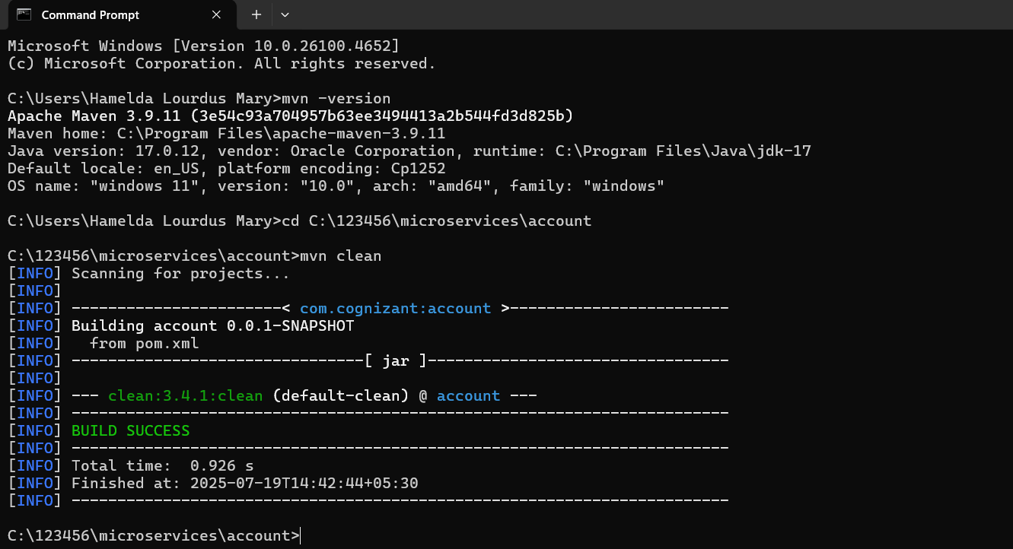

* Import this project in Eclipse and implement a controller method for getting account details based on account number

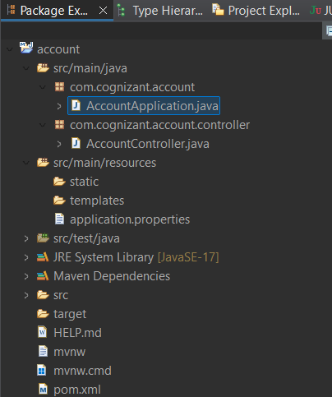

**AccountController.java**

package com.cognizant.account.controller;

import org.springframework.web.bind.annotation.GetMapping;

import org.springframework.web.bind.annotation.PathVariable;

import org.springframework.web.bind.annotation.RestController;

import java.util.HashMap;

import java.util.Map;

@RestController

public class AccountController {

@GetMapping("/accounts/{number}")

public Map<String, Object> getAccountByNumber(@PathVariable String number) {

Map<String, Object> response = new HashMap<>();

response.put("number", number);

response.put("type", "savings");

response.put("balance", 234343);

return response;

}

}

**Application.properties:**

spring.application.name=account

server.port=8081

* Launch by running the application class and test the service in browser

**Output:**

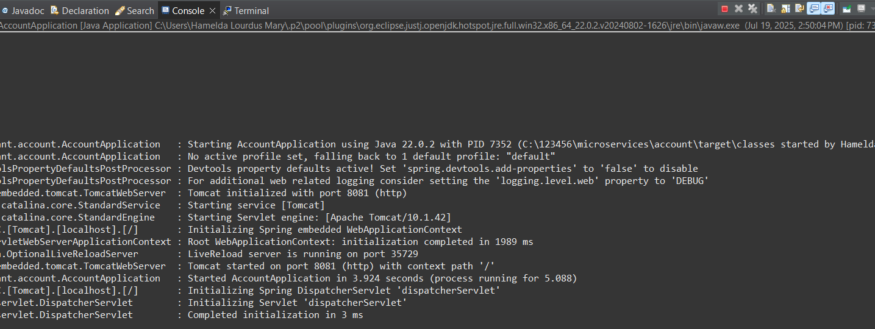

http://localhost:8081/accounts/00987987973432

**Chrome:**

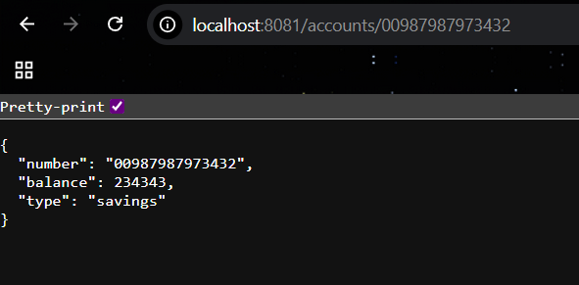

**Postman:**

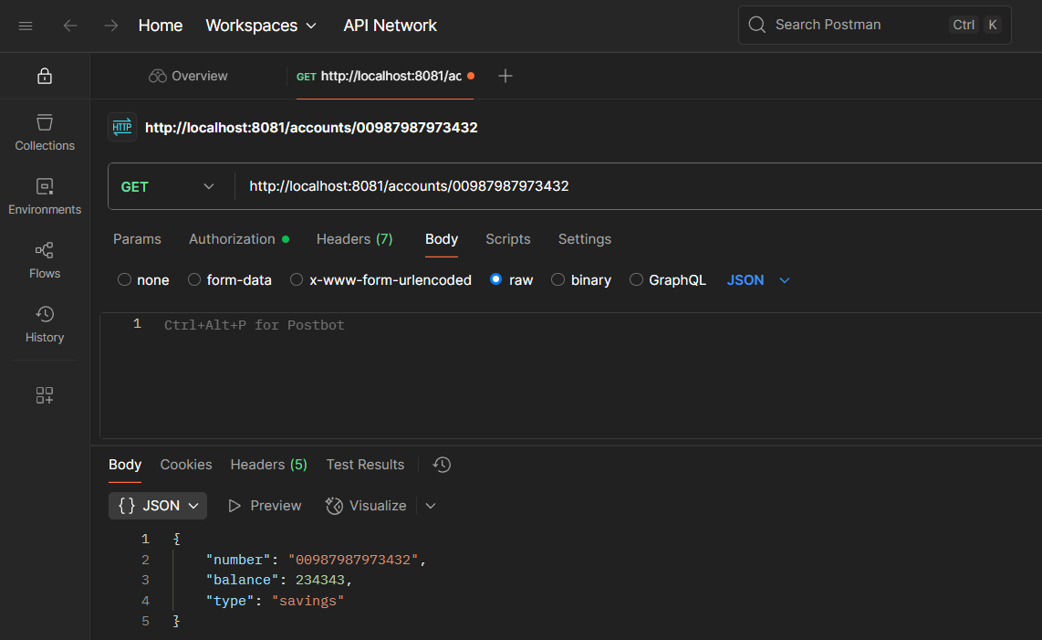

**Loan Microservice:**

**Open https://start.spring.io/ in browser •**

* Enter form field values as specified below:

**Group:** com.cognizant

**Artifact:** loan •

* Select the following modules :

Developer Tools > Spring Boot DevTools

Web > Spring Web •

* Click generate and download the zip file

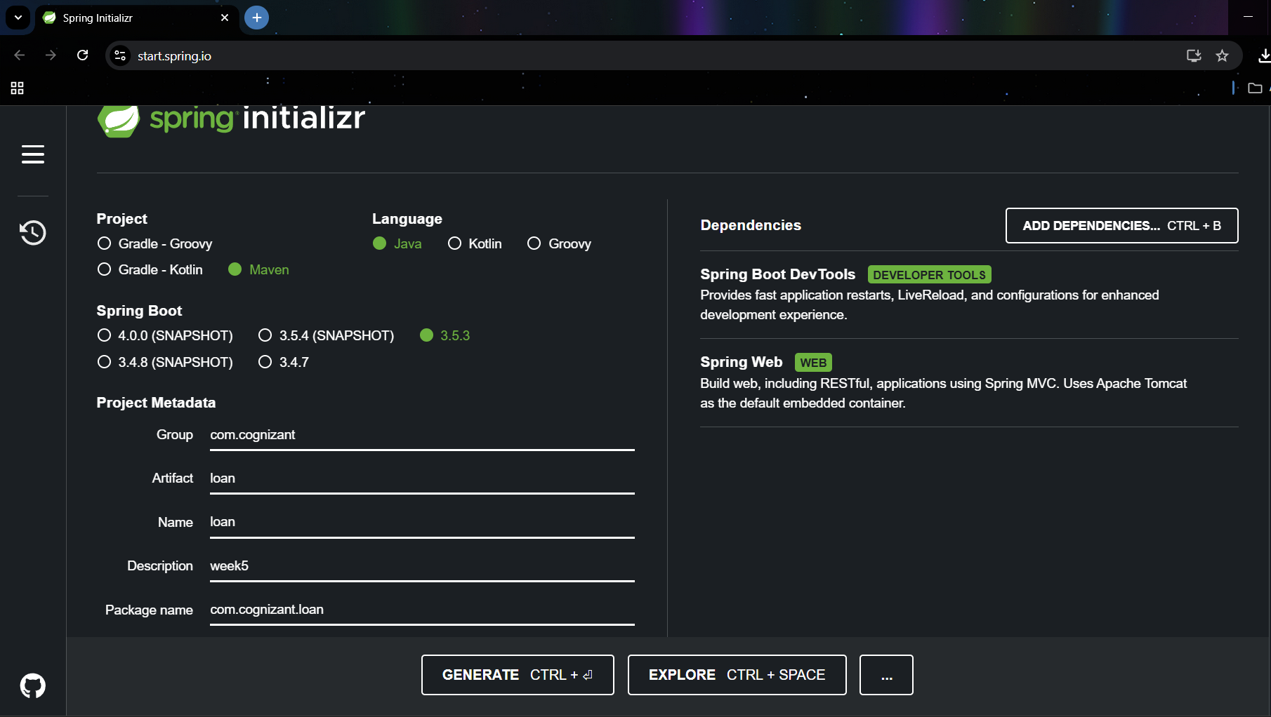

**Implement a service API to get loan account details**

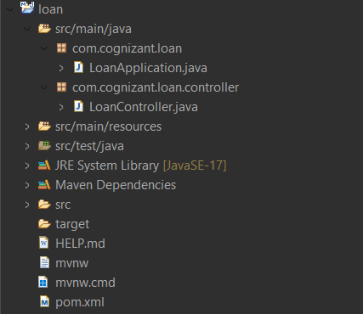

**LoanController.java:**

package com.cognizant.loan.controller;

import org.springframework.web.bind.annotation.GetMapping;

import org.springframework.web.bind.annotation.PathVariable;

import org.springframework.web.bind.annotation.RestController;

import java.util.HashMap;

import java.util.Map;

@RestController

public class LoanController {

@GetMapping("/loans/{number}")

public Map<String, Object> getLoanByNumber(@PathVariable String number) {

Map<String, Object> loanDetails = new HashMap<>();

loanDetails.put("number", number);

loanDetails.put("type", "car");

loanDetails.put("loan", 400000);

loanDetails.put("emi", 3258);

loanDetails.put("tenure", 18);

return loanDetails;

}

}

**Application.properties:**

spring.application.name=loan

server.port=8082

* **Launching this application by having account service already running**

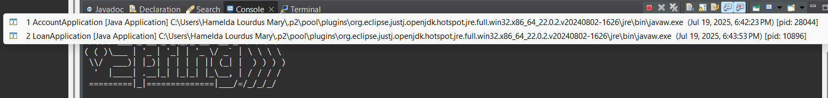

**Output:**

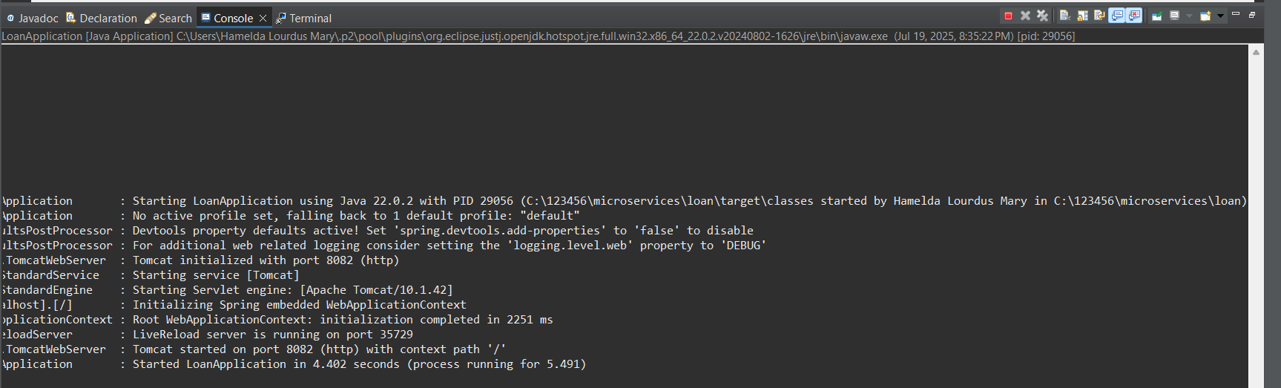

<http://localhost:8082/loans/H00987987972342>

**Chrome:**

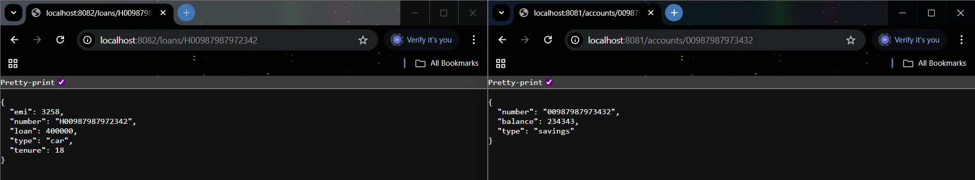

Now we have two microservices running on different ports

**Postman:**

